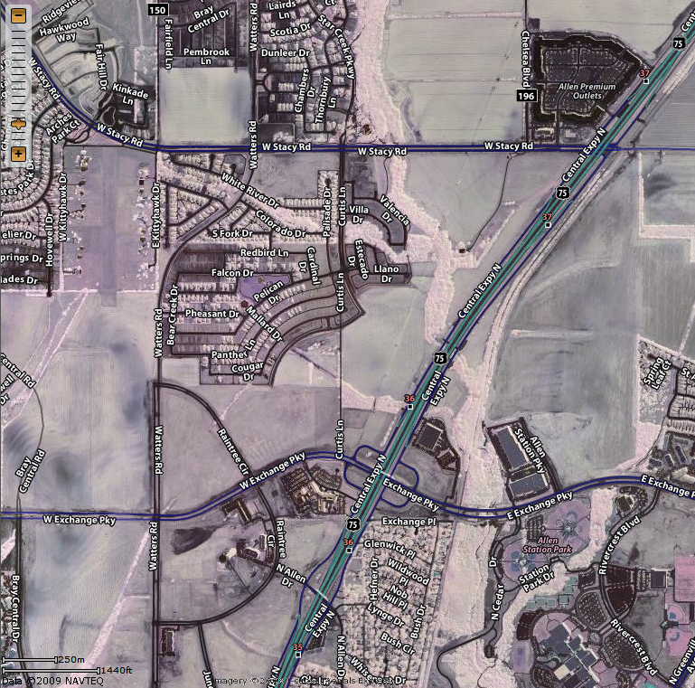
North from Plano on 75 - Central Expressway. Take Exchange Parkway West to Watters. Turn right (North) on Watters. Heritage Floors is on the West side of Watters Road..
South from McKinney on 75 - Central Expressway. Take Stacy Road West to Watters. Turn left (South) on Watters. Heritage Floors is on the West side of Watters Road..
New Construction
Shopping Center
Map courtesy of Yahoo Maps:
http://maps.yahoo.com

