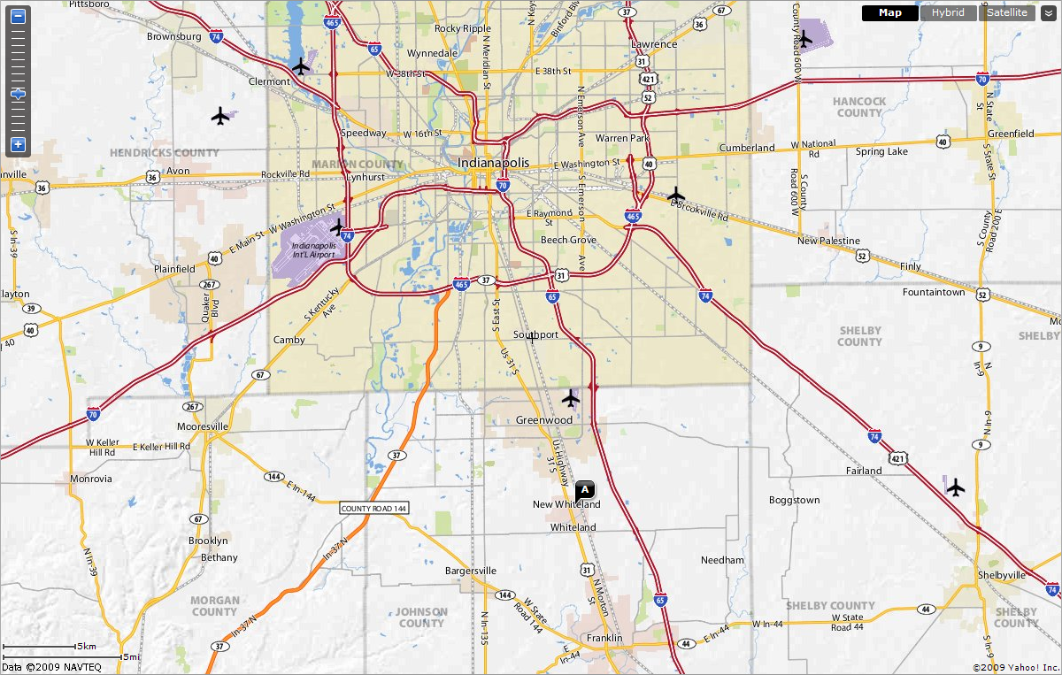

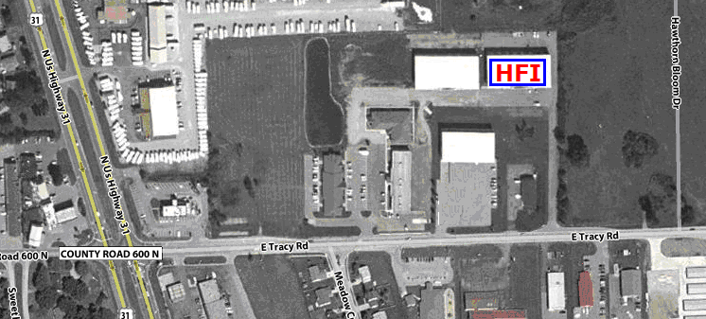
From Indianapolis, travel South on US Highway 31 to Tracy Road, turn left onto Tracy Road. Head East approximately 2/10^{ths} of a mile. Turn left into the driveway for Heritage Floors, Inc., 570 East Tracy Road, Suite 640, New Whiteland, IN 46184
(Local# 317-535-0800; Fax: 317-535-2600)

